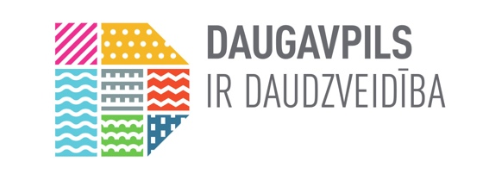

ESPLANADE WETLAND IN DAUGAVPILS TO BE DEVELOPED INTO AN IMPORTANT NATURE TOURISM AND ENVIRONMENTAL EDUCATION SITE

Daugavpils City Council in cooperation with the Municipal Administration of the Anykščiai Region in 2020 launched a joint Interreg V-A Latvia-Lithuania Cross-border Cooperation Programme project "Joint Management of Urban Wetland Areas in border region Latvia-Lithuania". The aim of the project “Joint Management of Urban Wetland Areas in border region Latvia-Lithuania / Urb-Area”, LLI-472 is to develop a new and effective approach to joint management of urban wetlands across the border.

The Esplanade Wetland, located in the central part of Daugavpils, has been selected as one of the target areas of the project. The hydrological regime of the Esplanade wetland area before the construction of the Daugavpils dam in 1830-1841 was determined by seasonal fluctuations in the water level of the Daugava River and its tributary, the Šuņupe River. The Esplanade Wetland has historically supported a biodiversity characteristic of river floodplain complexes. The course of the Šuņupe River and its connection to the Šuņezers Lake have been preserved, but the natural hydrological regime of the site has changed significantly over the course of urban development. Urban development has both altered the natural channel of the river and disrupted its course. Today, a fragmented riverscape has developed, which in its current state is no longer visually perceptible as a historically natural riverscape. However, despite significant environmental changes, the site has retained its historically natural character, which should be preserved in the future not only in the context of the Esplanade wetland, but also in the context of the whole Šuņupe River landscape.
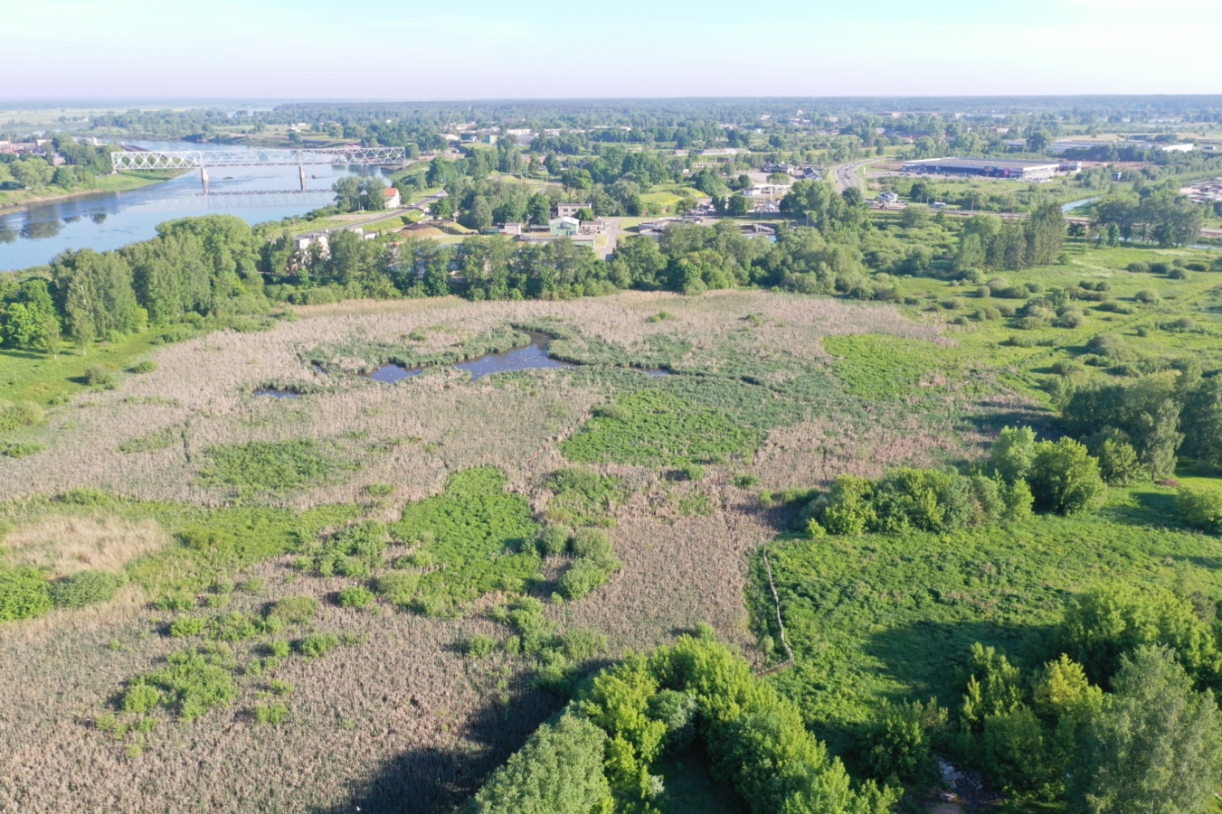
Esplanade Wetland from a bird's eye view (Photo: D. Lazdāns)

The area adjacent to the Esplanade Wetland is already an important recreational area, but it has a high potential to develop into a unique nature tourism and environmental education area in the future. Despite the high anthropogenic pressure, the Esplanade Wetland is characterised by an unusually high biodiversity for an urban environment. The most important asset of the Esplanade Wetland is the black-headed gull colony, where between 1000 and 2000 pairs of black-headed gulls nest each year. The area is also an important habitat for many other protected and rare species. In total, 22 species of special conservation concern or otherwise of nature conservation importance have been identified in the Esplanade Wetland and the adjacent area during surveys carried out as part of the project.

The biodiversity of the Esplanade Wetland is an essential prerequisite for the wetland area to provide the planned environmental educational functions in the future, however, when planning the development of the area in the long term, it is necessary to take into account that unconsidered development of new infrastructure may negatively affect the natural values found in the area. In order to mitigate the potential negative impact of the construction and operation of the infrastructure planned for the Esplanade Wetland, the team of experts involved in the implementation of Urb-Area project No.LLI-472 developed recommendations for the future development of the Esplanade Wetland, respecting both the intentions of the Daugavpils City Municipality to create an environmental education facility in the area, and offering specific solutions for the conservation and enhancement of biodiversity.

By improving the area, it will also become attractive to local residents as a recreational place - for walking, socialising, active lifestyle, as well as an attractive area for visitors. The Esplanade Wetland can also be used in the future as a natural platform for the Latgale Zoo and Daugavpils Innovation Centre.

Program is funded by European Regional Development Fund (ERDF). The total ERDF funding for the Program for project funding is EUR 69 600 000.
The contents are the sole responsibility of Daugavpils City Municipality and can under no circumstances be regarded as reflecting the position of the European Union.

Further information:
Head of development of the management plan
Dr. biol. Uldis Valainis
Tel.: 26113065
E-mail: uldis.valainis@biology.lv

